Key Enquiry – Is Europe the same all over? |  |  | Knowledge Organiser – Year 4 |  | Summer Term
VOCABULARY |  | 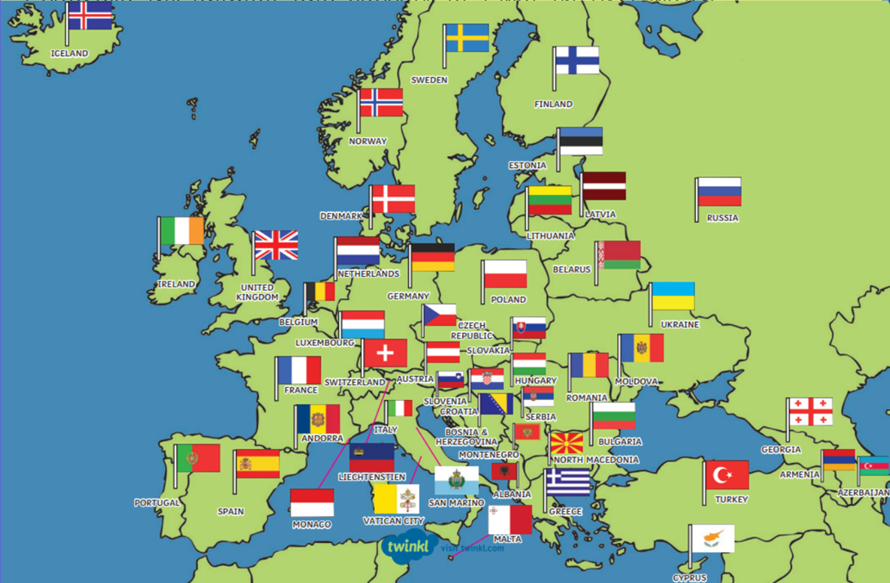 |  | KEY PLACES
Region | an area of the earth's surface that has certain features of land and climate |  |  | Europe |  | The world’s second smallest continent that is between Asia and the Atlantic Ocean and is north of the Mediterranean Sea. Europe is in the Eastern Hemisphere.
Climate | the usual weather conditions in a place |  |  | North West England |  | North West England is one of nine official regions of England and consists of the administrative counties of Cheshire, Cumbria, Greater Manchester, Lancashire and Merseyside
Topography | the shape of the earth's surface across an area or region. This includes the size and location of hills and dips in the land. |  |  | France |  | Bounded by the Atlantic Ocean and the Mediterranean Sea, the Alps and the Pyrenees, France has long provided a geographic, economic, and linguistic bridge joining northern and southern Europe. It is Europe’s most important agricultural producer and one of the world’s leading industrial powers.
Longitude | distance on the earth's surface east or west of an imaginary line on the globe that goes from the north pole to the south pole. |  |  | The Rhine |  | The Rhine River is the 11th longest river in Europe, stretching approximately 1,230 kilometers from its source in Switzerland to its mouth on the North Sea in the Netherlands. It flows through six countries; Switzerland, Germany, Austria, Liechtenstein, Germany, and the Netherlands.
Latitude | the distance between the equator and a point north or south on the earth's surface. | Key Facts
Latitude |  | - There are at least 44 countries in Europe and 742 million people living there which is 10% of the world’s population.  - Europe is in the northern hemisphere with the Artic Ocean to the north, the Atlantic Ocean to the west and the Mediterranean Sea to the south.  - The largest country in Europe is Russia and the smallest is Vatican City.  - The highest mountain in Europe is Mount Elbrus in Russia (5642m) and the longest river is the Volga river in Russia (3693km).  - There are 24 official languages spoken in Europe with Russian being the most spoken language. English is the 5th most spoken language in Europe.  - The Louvre in France is the most visited attraction in Europe.  - The World’s happiest place to live is Finland according to the World Happiness Report!
Location | place or position.
Country | a large area of land where people live under the same government or have the same culture; nation.
Tundra | one of the huge plains in the arctic regions of North America, Europe, and Asia.
Ice Cap | a large, thick sheet of ice that spreads out over the land in all directions from the center. | Key Diagrams
Ice Cap |  | 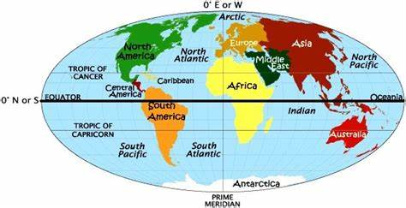  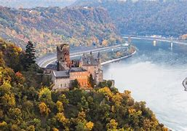  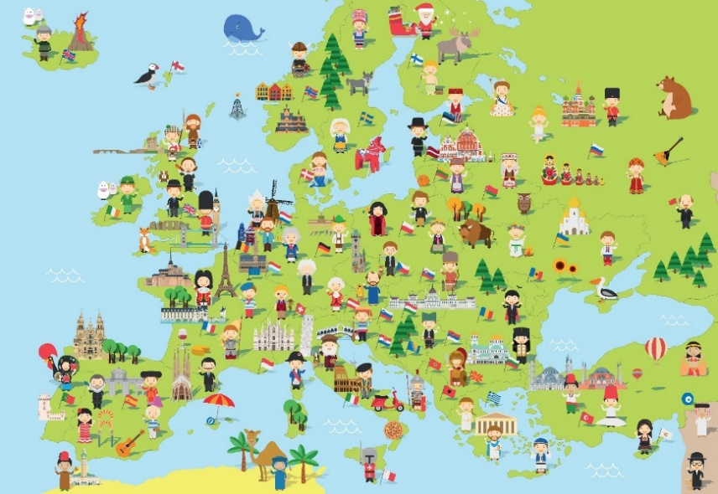
Grassland | a large area of land covered by grass.
Borders | the line between two countries, states, or towns
Continent | one of the earth's seven major areas of land. The continents are Africa, Antarctica, Asia, Australia, Europe, North America, and South America.

