Enquiry Question Is the UK the same all over? Knowledge Organiser – Year 2 Autumn term
VOCABULARY DOZEN |  | 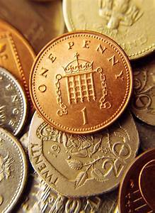  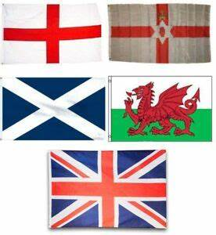  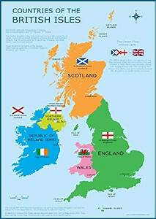 | KEY PEOPLE
Great Britain (G.B.) | The name often given to the countries of England, Scotland and Wales. |  | 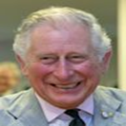 | King Charles III became king of the UK on September 8th 2022 when Queen Elizabeth II died.
United Kingdom (U.K.) | The 4 countries of England, N. Ireland, Scotland and Wales. |  | 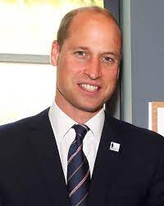 | Prince William, the Prince of Wales, is the king’s elder son. he is the heir to the throne so should be the next king.
The British Isles | The British Isles are of the islands of Great Britain, Ireland and other small islands. |  | 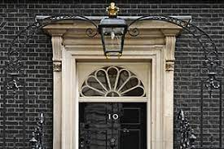 | 10 Downing Street in London is where the Prime Minister lives. They are the person who is in charge of the laws in the country and are voted for in a democratic election.
England | The largest country in Great Britain and the U.K.
Scotland | The country in the north of Great Britain and the U.K. | KEY FACTS
Wales | A principality in the west of Great Britain and the U.K. | - The population of the U.K. is 66.5 million.  - The currency is pound sterling (£)  - The UK is a large country covering about 93,600 square miles but nowhere in it is more than 75 miles from the sea.  - The National Anthem is ‘God Save the King.’  - The National Symbol is a Lion, the flag is known as the Union Jack and the national colours are red, white and blue.  - In 1707, the first political union of the Kingdom of England which then included Wales and Scotland was formed. In 1922 Northern Ireland joined this Union. From 1835 until 1925 the city of London was the largest city in the world. In 1927 the UK was officially proclaimed. From 1973 - 2020, the UK was part of the European Union.  - The UK lies on the prime meridian which marks the Greenwich meridian timezone (GMT)  - The UK has the third longest coastline in Europe with 12,430 km.  - The United Kingdom's highest mountain is Ben Nevis in Scotland with 1,345 m/4,412 ft.  - The largest lake in the UK is Lough Neagh in Northern Ireland.  - Loch Ness, in Scotland, is the largest fresh water lake (by volume) in the UK.  - The longest river in the UK is the River Severn in England, which is 354 km/ 220 miles long.  - London Heathrow is the biggest airport on the European continent.
Northern Ireland | Northern Ireland is a part of the United Kingdom.
London | London is the capital and largest city of England and the United Kingdom.
Edinburgh | The capital city of Scotland.
Cardiff | Cardiff is the capital city of Wales.
Belfast | Belfast is the capital and largest city of Northern  Ireland.
Europe | The continent which the U.K. is part of.

