Title: Explore and Draw Knowledge Organiser – Year 2 - Autumn Term
VOCABULARY DOZEN |  | 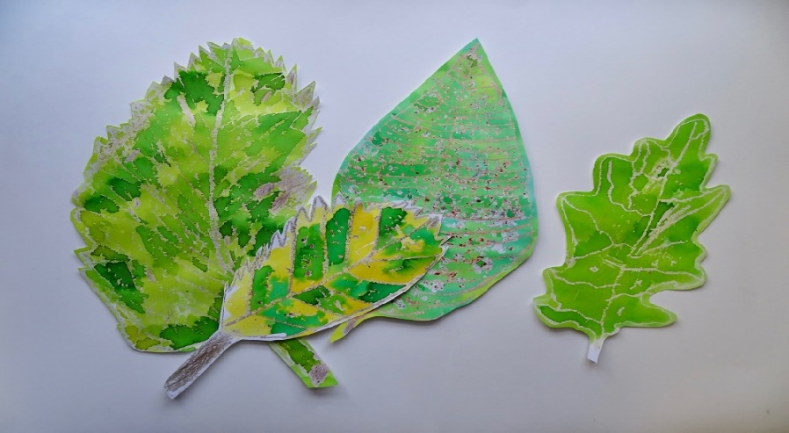 | KEY ARTISTS
artist | a person engaged in an activity related to creating art. |  | Nicola White is a “Mudlarker” and artist, who uses the glass she finds on the beach to make her artworks.
natural | coming from nature; not made by humans |  | 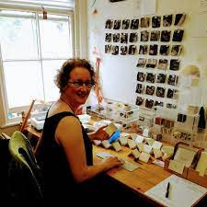  Alice Fox is an artist exploring found, gathered and allotment- grown materials.
material | things needed for an activity
observational drawing | Drawing what you can see =
line | a mark or stroke that is longer than it is wide. | 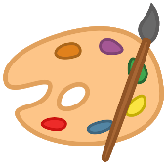  Key concepts and Outcomes
colour | change the colour of (something) by painting, dyeing, or shading it | That we can use the things we find to draw from, using close observational looking.  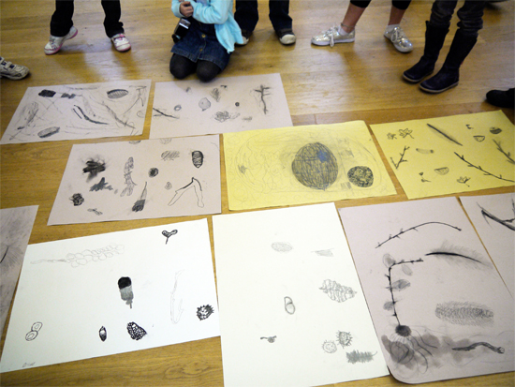  That we can go into our own environments, even when they are very familiar to us, and learn to see with fresh eyes and curiosity.  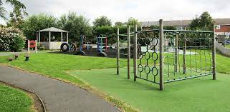  That artists explore the world, seeing things around them in new ways, and bring things back to their studios to help them make art.  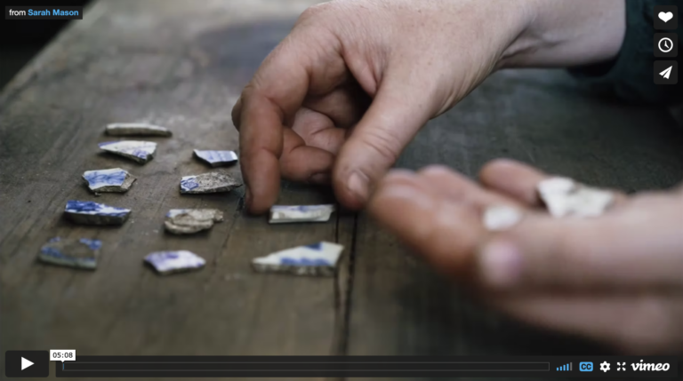  I can discuss and reflect on my artwork.  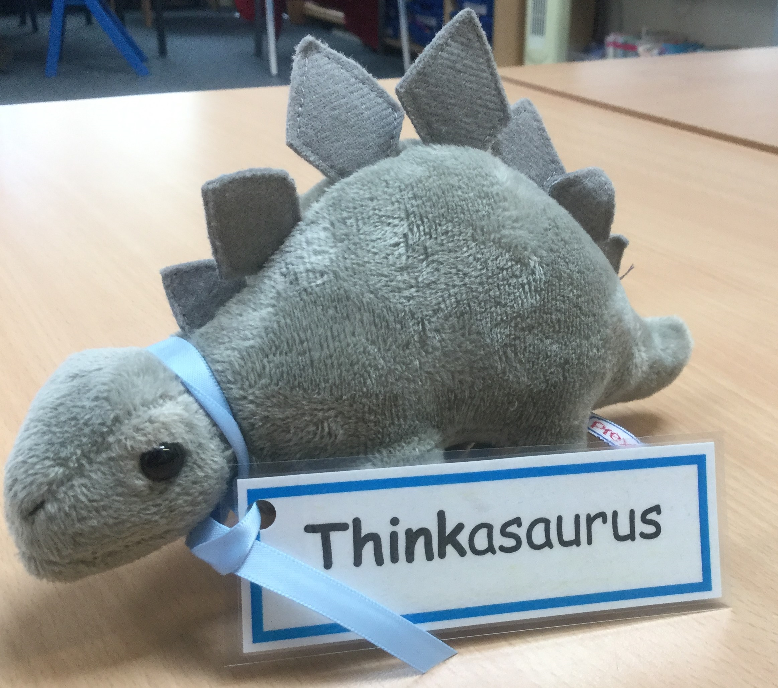  I can explore observational drawing and experimental mark making and think about how I can use composition to create my artwork.  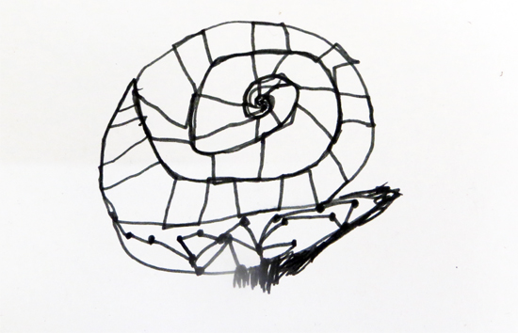  To develop my ideas using a sketchbook.  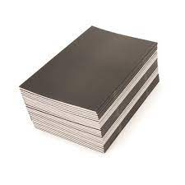
photograph | a picture or likeness obtained by photography.
shape | the external form, contours, or outline of someone or something.
watercolour | Paint which consists of fine pigment particles mixed with water
graphite | Soft dark pencils used for drawing
wax resisit | strokes are made with clear wax then overpainted with watercolour.
composition | the arrangement of elements within the pictorial space

